Title of Abstract

Any Author¹, Another Author¹, Presenting Author², and Final Author^{1,2}
¹ Department of Physics, Okayama University, Okayama 700-8530, Japan
²Department of Physics, Kyoto University, Kyoto 606-8502, Japan

Abstracts should be written in English, and is limited to Word within one page of A4 vertical format in 11-arial, single-spaced. At the top of the document, centered in bold, caps and lower case, type the title of the abstract. Insert a blank line. All authors should be listed on the next line(s) followed by their institution(s). Use numbers to indicate the different affiliations of the authors. Underline the name of the author who will present at the conference. The author list and author affiliation list should be centered. Insert another blank line between the authors and the body of the abstract.
Start each paragraph of the body of the abstract with a tab.
Each figure included in the abstract should be accompanied by a caption in 11-Arial. Be sure that figures are neatly prepared and fit within the space limitations.
Call out references [1,2] in the text with a numeral in brackets. Number all references sequentially as they appear in the text, starting with 1. Make all references complete bibliographic citations, including author, place of publication, volume, year, and first page. Reference should follow the main text of the abstract.
This is the MSWord template for abstract preparation.
The deadline for submission of abstracts is 28 February 2025.
Please do not modify the format of this abstract.

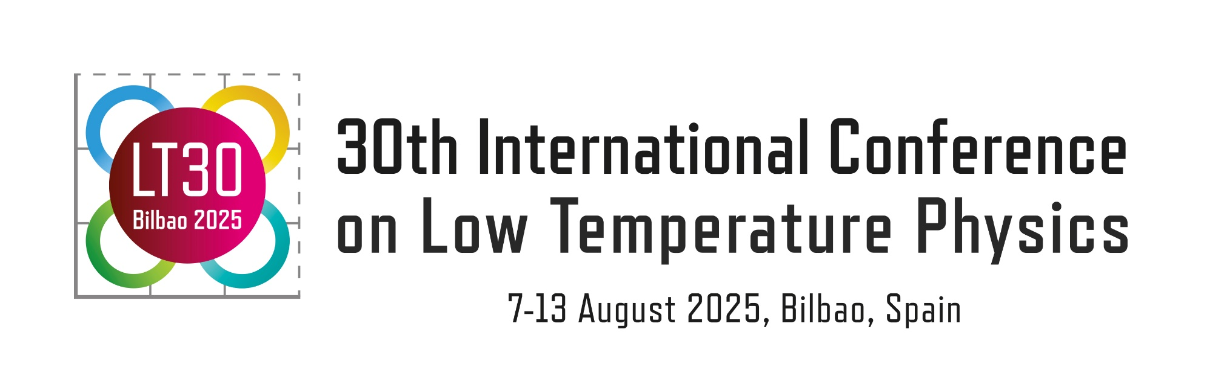

Figure 1: My figure.

*This work was supported by the Program Committee.
[1] A. Author et al., Phys. Rev. B 1, 1 (2020).
[2] A. Author and B. Author, J. Phys. Soc. Jpn. 1, 1 (2022).

